Step 15. Valve Calibration
Within this section, you will work through the automatic calibrations for each of the valves that control the linkages. This valve calibration allows Earthworks to measure and record the valve responses for each individual hydraulic valve.
The machine’s linkages will move during this process. Ensure that there is enough room available for the linkages to move throughout their entire range of movement. Each linkage will be calibrated individually.
Navigate to the Valve Calibration menu within the Install Assistant.
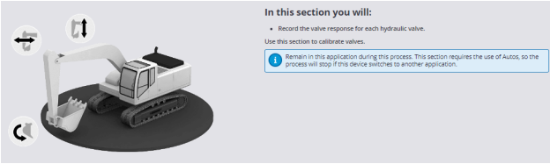
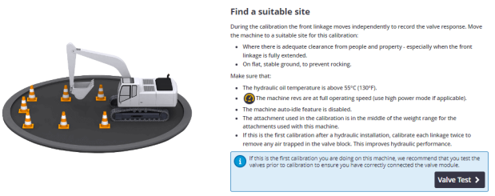
Step 1: Boom Calibration
1. Select Boom Calibration to start.
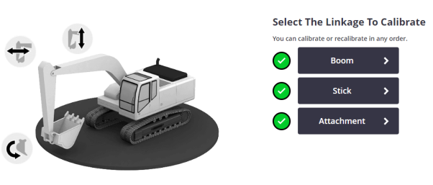
2. Position the machine in the shown orientation and set the lower calibration
limit. This step limits the calibration movement range.
- The attachment and stick must be fully curled
- Boom is at its lowest possible position
Raise the boom slightly if the cylinder has internal dampeners as contact with the dampeners during the calibration may skew measurements.

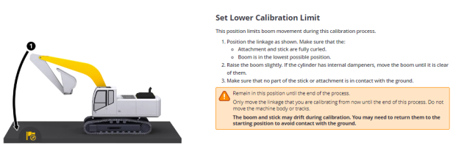
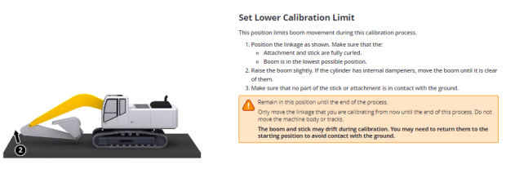
3. Select Begin Reading.
4. Set the upper calibration limit. Raise the boom so the boom cylinder is vertical.
Lower the boom slightly to avoid contact with internal dampeners.
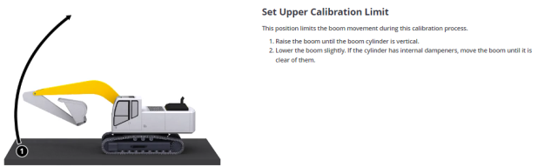
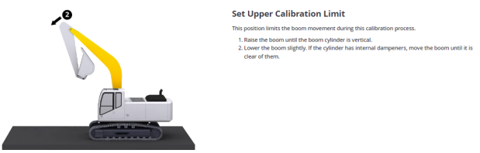
5. Select Begin reading.
6. Return the boom to the middle position. The green check mark will appear once
in the correct position.
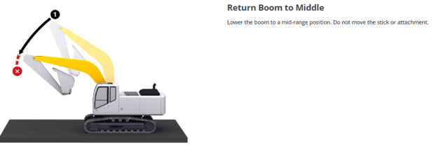
7. Select Next to move to the next step.
8. Press, hold, and then release the auto switch to proceed. Ensure the following
conditions have been met:
- Site is clear and ready for full extension of the machine linkages.
- The machine is at full RPM and at operating temperature.
- Any Hydraulic Lockouts are disabled.
9. Follow on screen prompts to complete the valve calibration for the Boom.
Step 2: Stick Calibration
1. Enter the Stick Calibration menu
2. Set the Retracted Calibration Limit.
- Curl the attachment in fully
- Boom cylinder must be vertical
- Stick is slightly above vertical
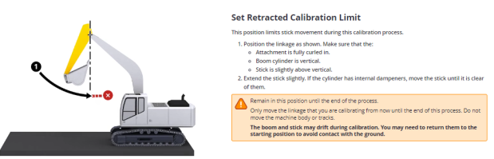
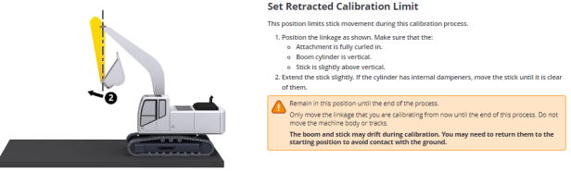
3. Select Begin Reading.
4. Set Extended Calibration Limit
- Raise the stick until it is completed extended
- Lower stick slightly to avoid internal dampeners
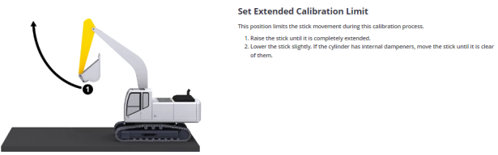
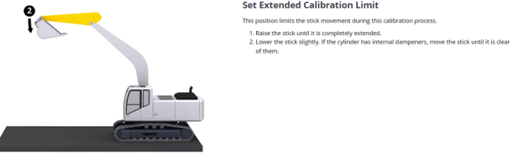
5. Select Begin Reading.
6. Return the stick to the middle position. The Green checkmark will appear once
in the correct position.
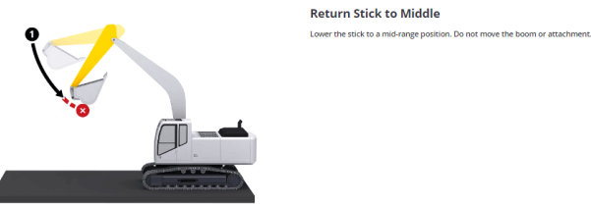
7. Arm the valves by pressing, holding, and then releasing the autos switch.
8. Allow the automated Stick calibration to complete while following on screen
prompts.
Step 3: Attachment Calibration
1. Enter the Attachment Calibration menu.
2. Set the Upper Calibration Limit:
- Position the machine as shown in the diagram
- Stick must be curled to ensure that the attachment can move without contacting the boom.
- Boom is raised so that the attachment can uncurl without contact with the ground
- Attachment is fully curled
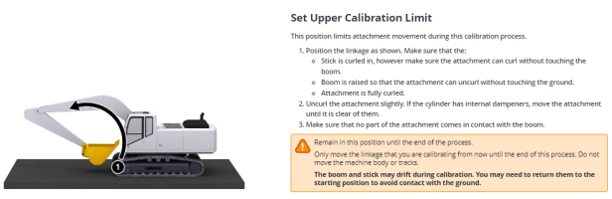
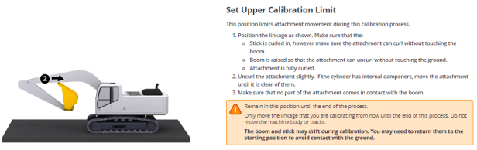
3. Uncurl the attachment slightly to avoid contact with internal dampeners.
4. Select Begin reading.
5. Set the Lower Calibration Reading:
- Uncurl the attachment as shown.
- Curl the attachment in slightly to avoid internal dampeners.
- Make sure that the attachment cannot come into contact with the ground.
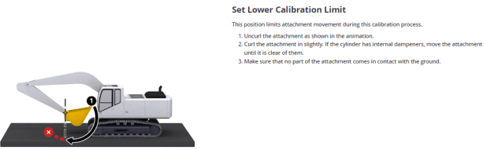
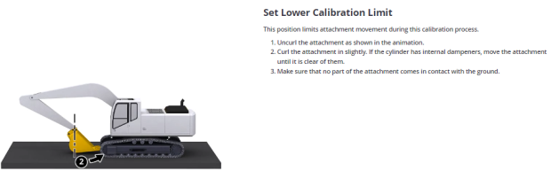
6. Return the attachment to its center position. The Green Checkmark will appear
once it is in the correct position.
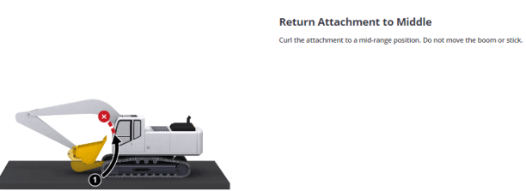
7. Arm the valves as you have in the last 2 steps and follow on screen prompts to
complete the attachment valve calibration.

